**Bellringer: Signal Transduction Pathway Diagram**

AP Biology

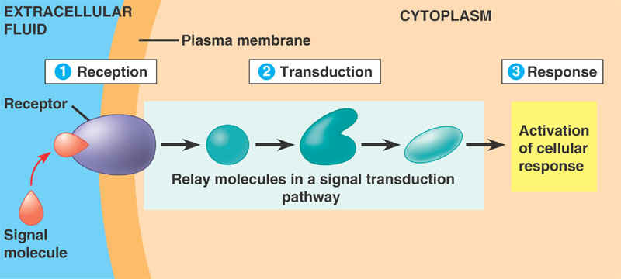

**Describe** the type of molecule the receptor in this model most likely is composed of.

**Predict** what would happen if the receptor molecule’s shape were to be changed in some way.

**Explain** how the transduction process here is like a set of dominoes that fall.

**Describe** a cellular response that could be elicited from this type of signaling pathway.

**Bellringer: Signal Transduction Pathway Diagram**

AP Biology



**Describe** the type of molecule the receptor in this model most likely is composed of.

**Predict** what would happen if the receptor molecule’s shape were to be changed in some way.

**Explain** how the transduction process here is like a set of dominoes that fall.

**Describe** a cellular response that could be elicited from this type of signaling pathway.